 | Filing Reference : |  | GG/COMS/TS.2/2
 | Document Title : |  | Use-Case Realization Report (Analysis)  Export Cylinder Queues Information
 | Version : |  | 1.0
 | Prepared By : |  | Koh Ming Jin
 | Date Created : |  | Monday, Apr 29th, 2011
Approved By :
 |  | Tran Ba Tien |  | Date
 |  | Project Manager |  | 29th Apr 2011
©2011 [Hoang Kim joint stock Company].
The information contained in this document is the property of [Hoang Kim joint stock Company]. The contents must not be reproduced, wholly or in part, for purposes other than for which it has been supplied, without the prior permission of [Hoang Kim joint stock Company], or, if it has been furnished under contract to another party, as expressly authorised under that contract. [Hoang Kim joint stock Company] shall not be liable for any errors or omissions.

Revision History
Date | Version | Description | Author
29/Apr/2011 | 1.0 | Initial Document | Koh Ming Jin

Table of Contents
1. Brief Description 4
2. Flow of Events 4
2.1 Standard Flow 4
2.1.1 Log-In 4
2.1.2 User Functions 4
2.1.3 Log-Out 4
2.2 Exception 4
3. Interaction Diagrams 5
3.1 Collaboration Diagram for Export Cylinder Queues Information 5
4. Participating Objects 5
4.1 Operation Manager 5
4.2 Main Page 5
4.3 Role Main Page 5
4.4 Main Controller 5
4.5 Workflow Controller 6
4.6 Step Controller 6
4.7 Cylinder Controller 6
4.8 Step 6
4.9 Cylinder 6
4.10 Workflow 6
5. Class Diagrams 6
5.1 Domain Class Diagram: Export Cylinder Queues Information 6
6. Derived Requirements 7

Use-Case Realization Report
Export Cylinder Queues Information

Brief Description
This use case enables an operation manager to export the cylinder queues information.

Flow of Events
The standard flow of events for this use case and any exceptions are described in the following subsections. See section 3.1 for an overview of the participating Actors and Domain Objects.

Standard Flow
The flow of events is described as follows:

Log-In
To commence using the system, the Operation Manager is required to log-in successfully as follows:
- Refer to Log In Use Case for details.

User Functions
- The use case starts when Operation Manager selects the Export Queue option (operation exportQueue of the MainPage). This will redirect to the RoleMainPage.
- To get the Workflow, the following will be performed:
  - Operation exportQueue (RoleMainPage & MainController) will be used to retrieve all the workflow details by calling the operation getAllWorkflowID of the WorkflowController.
  - WorkflowController will return the workflow objects (using operation retrieveWorkflowInfo).
  - The list of workflow will be shown in the RoleMainPage (i.e. operation show)
- The Operation Manager can click on a particular workflow (operation selectWorkflowID) and select export Queue information using the operation exportCylinderQueue.
- The Main Page will call the MainController’s “exportCylinderQueue” operation, which will then call the WorkflowController’s operation (exportQueue).
- The WorkflowController will call the StepController’s retrieveStepsForWorkFlow to retrieve all the Steps objects (operation retrieveStepInfo) which belong to the selected workflow ID.
- Moreover, the WorkflowController will then retrieve the list of cylinders for each of the Steps using the operations: retrieveCylinderList and retrieveCylinderInfo.
- The WorkflowController will return the queue information and display the information on the Main Page (using operation show).

Log-Out
- The Operation Manager will terminate use of COMS (ie: log-out) by pressing a button with the caption “Log Out”.
- Refer to the Log Out Use Case for details.

Exception
- File destination location not found. If the destination location is not found, a warning message will display to alert the user that the export process has failed.
- Read/Write access rights for the destination location. If the user account does not have the read/write access rights, a warning message will display to alert the user that the export process has failed.

Interaction Diagrams

Collaboration Diagram for Export Cylinder Queues Information

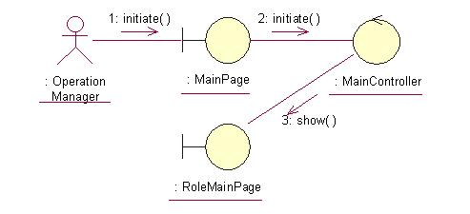
The above collaboration diagram shows the process flow after the actor has login.

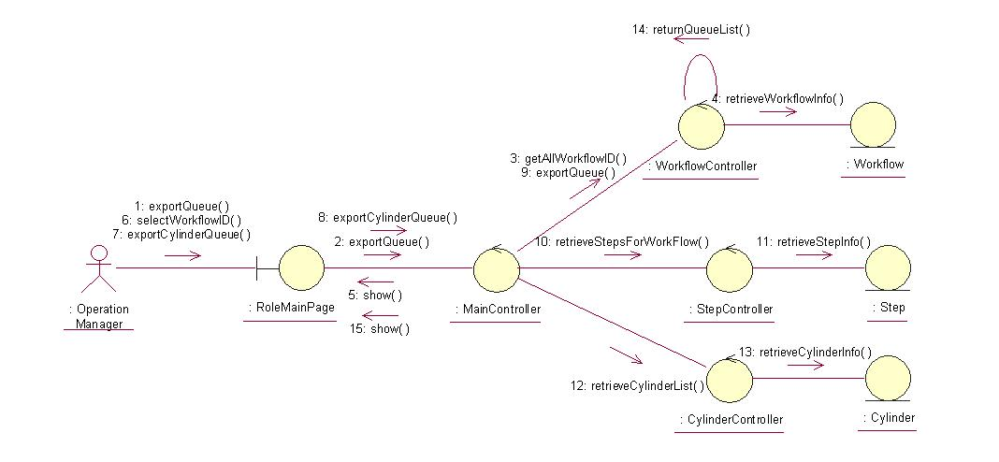
The above collaboration diagram shows the main process flow of this use case.

Participating Objects

Operation Manager
This actor represents the operation manager who will have a web page console to monitor and update the cylinder manufacturing operation.

Main Page
This object renders the contents after the actor has login. The Director, Department Manager and Operation Manager actors use this object.

Role Main Page
This object renders the contents (based on the user role) after the actor has login. The Director, Department Manager and Operation Manager actors use this object.

Main Controller
This object acts as the middleman between Main Page and the Workflow Controller. It will translate interactions with the view into actions to be performed by the Workflow Controller.

Workflow Controller
This object acts as the middleman between “Export Cylinder Queues information” Page and the Step Controller object. It will translate interactions with the view into actions to be performed by the Step Controller, Cylinder Controller, Step and Cylinder objects.

Step Controller
This object acts as the middleman between Workflow Controller and Step object. It will translate requests by Workflow Controller into actions to be performed by the Step object.

Cylinder Controller
This object acts as the middleman between Step Controller and the Cylinder object. It will translate requests by Step Controller into actions to be performed by the Cylinder object.

Step
This object stores the details concerning the step information of the COMS.

Cylinder
This object stores the details concerning the cylinder information of the COMS.

Workflow
This object stores the details concerning the workflow information of the COMS.

Class Diagrams

Domain Class Diagram: Export Cylinder Queues Information
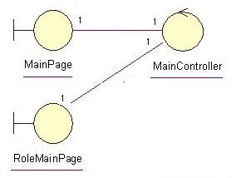
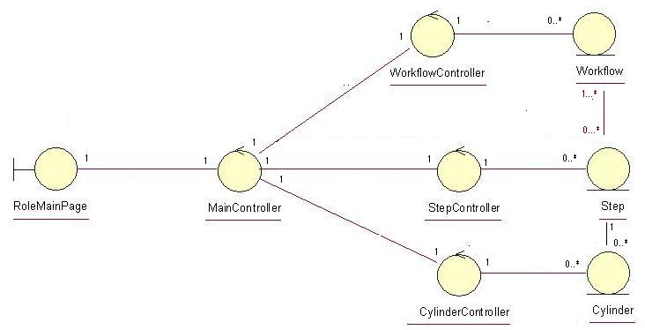

Derived Requirements
The Operation Manager PC keyboard and mouse will be used to retrieve queue details (if any) and view all the system responses.

